**Project Planning Phase**

**Project Planning Template (Product Backlog, Sprint Planning, Stories, Story points)**

|  |  |
| --- | --- |
| Date | 15 February 2025 |
| Team ID | SWTID1741256970149949 |
| Project Name | Rhythmic Tunes |
| Maximum Marks | 5 Marks |

**Product Backlog, Sprint Schedule, and Estimation (4 Marks)**

### 1. Product Backlog

The product backlog is a prioritized list of features and enhancements, much like a setlist for a concert where each tune is carefully chosen to build the overall experience.

| **ID** | **Feature** | **Description** | **Priority** | **Story Points** | **Rhythmic Analogy** |
| --- | --- | --- | --- | --- | --- |
| 1 | User Registration & Authentication | Allow users to sign up, log in, and manage their accounts securely. | High | 8 | Tuning instruments before the performance. |
| 2 | Music Playback & Streaming | Core functionality to stream music with essential controls (play, pause, skip, etc.). | High | 13 | The continuous, driving beat that keeps the rhythm alive. |
| 3 | Music Discovery / Search | Enable users to search for songs, artists, albums, and genres. | Medium | 8 | Exploring a rich library of musical notes and themes. |
| 4 | Playlist Creation & Management | Allow users to create, edit, and manage playlists. | Medium | 5 | Arranging setlists for a memorable concert. |
| 5 | Social Sharing & Interaction | Integrate features for sharing tracks, liking, and commenting; connect with social media. | Medium | 8 | An impromptu jam session where fans connect and share. |
| 6 | Offline Mode & Downloading | Enable downloading of songs or playlists for offline listening. | Medium | 8 | Carrying favorite tunes on the go for anytime inspiration. |
| 7 | Personalized Recommendations | Analyze user behavior to provide tailored song and playlist suggestions. | High | 13 | A conductor adapting the setlist to the audience’s vibe. |
| 8 | High-Quality Audio Support | Support multiple streaming qualities and adaptive streaming to match network conditions. | High | 8 | Crisp, clear notes that elevate the performance. |
| 9 | Analytics & Reporting | Track user behavior and system performance to continuously improve the service. | Low | 5 | Fine-tuning the performance based on live feedback. |
| 10 | Security Enhancements | Implement additional encryption, secure protocols, and data protection measures. | High | 8 | Securing the backstage to protect the precious score. |

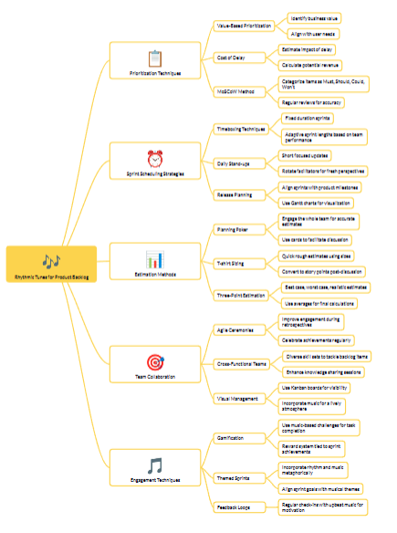

**Project Tracker, Velocity & Burndown Chart**

| **Component** | **Description** | **Rhythmic Analogy** |
| --- | --- | --- |
| **Project Tracker** | A centralized tool (e.g., Jira, Trello, Asana) used to monitor tasks, track sprint progress, and manage deadlines. | Like a conductor’s score that guides each instrument’s entry and exit, ensuring every note is played on cue. |
| **Velocity** | A metric that measures the amount of work (in story points) a team completes in a sprint, indicating the pace of progress. | The tempo of the band, setting the speed at which the performance (project work) moves forward. |
| **Burndown Chart** | A visual graph showing the remaining work versus the time left in a sprint, ideally displaying a steady downward trend. | Similar to counting down the remaining beats in a song, signaling the approach of the grand finale. |

